Weather Web

A website showing the environment in selected areas of the world in real time

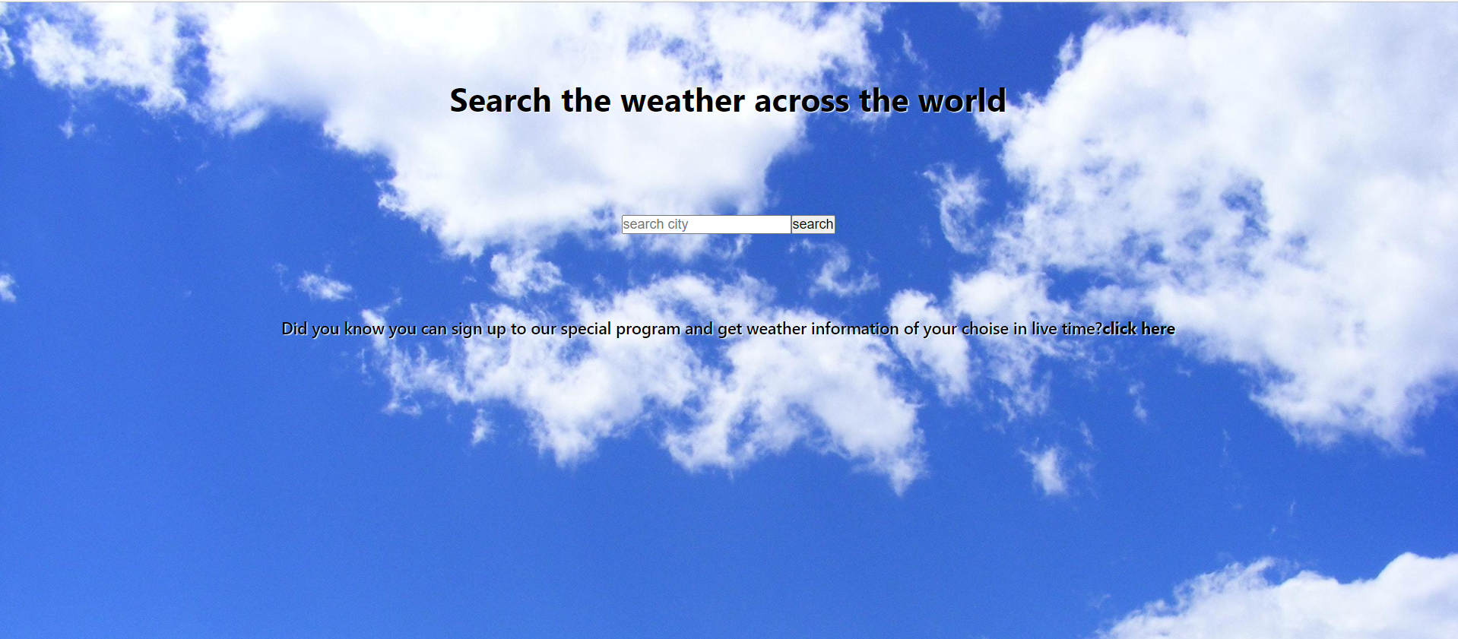

You search for the desired city or country in the search box and the site fetch the information from an external API

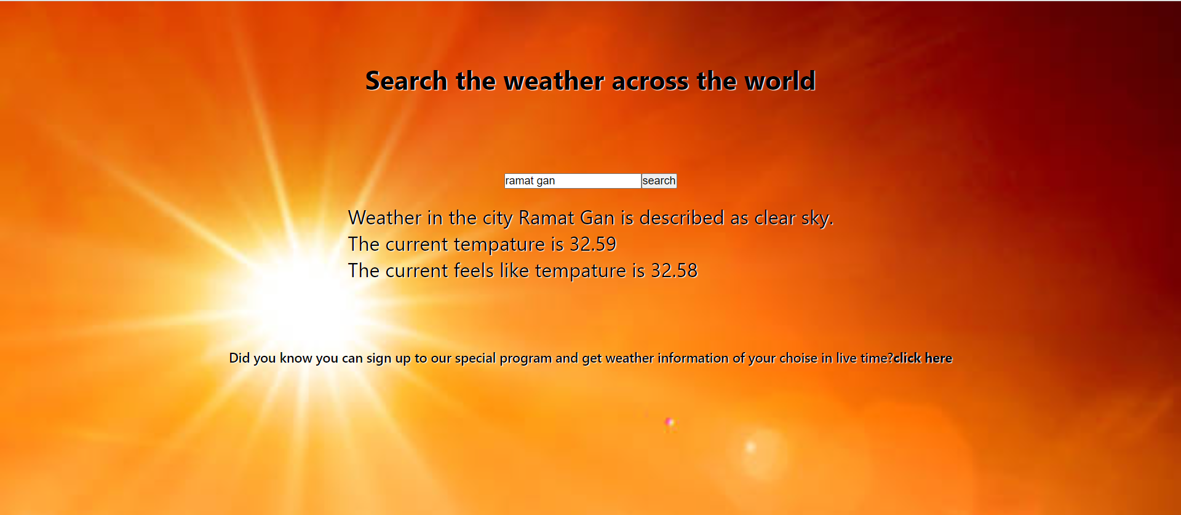

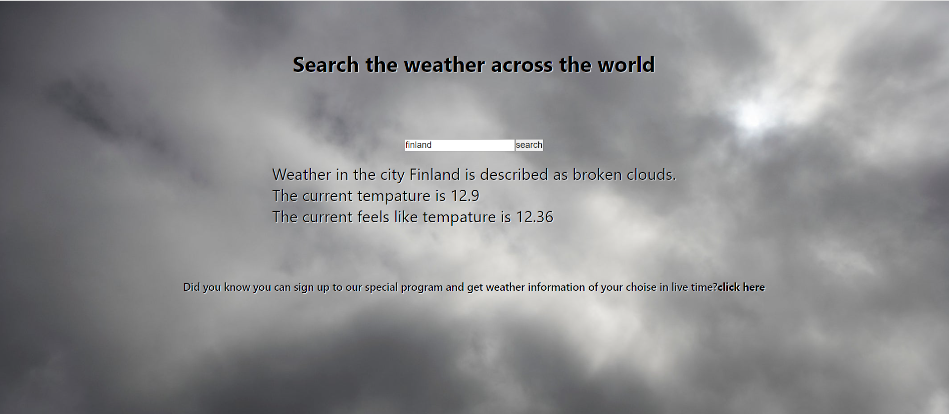

I also added a nice feature to make the site less boring.

The feature offers the user to register on the site and enjoy the ability to receive reports to the email when the temperature in a certain city crosses the defined range.

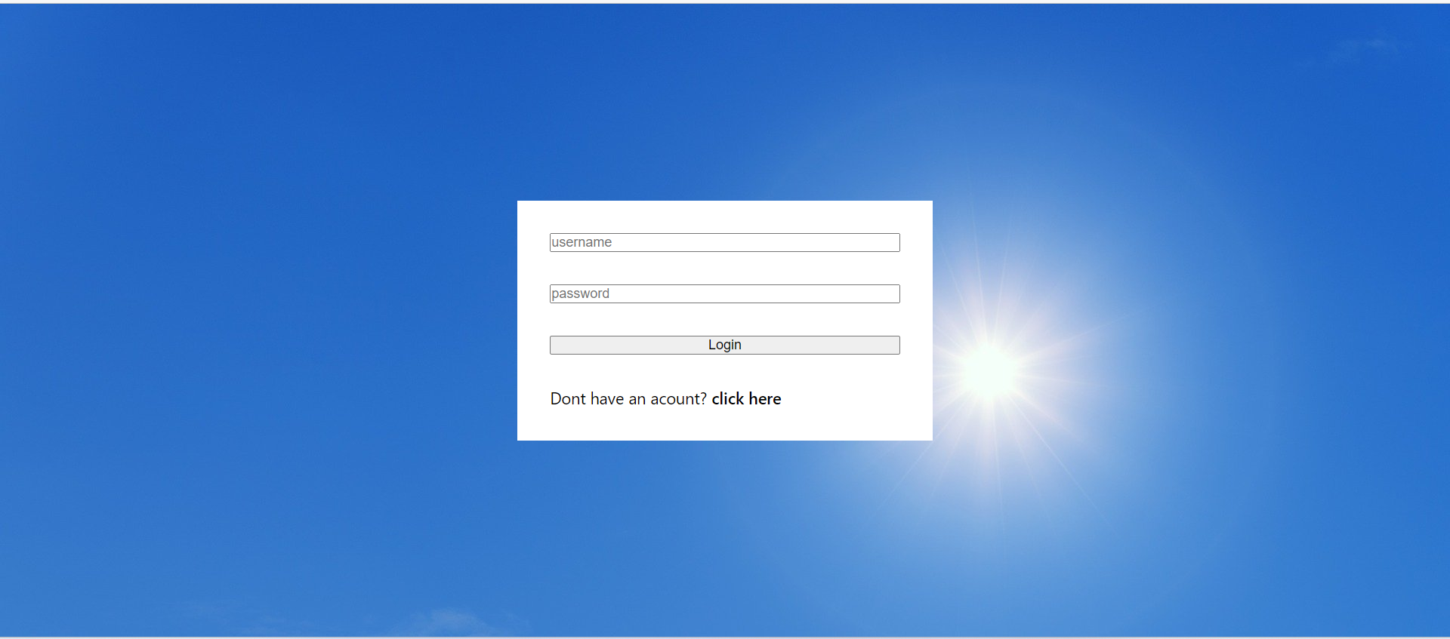

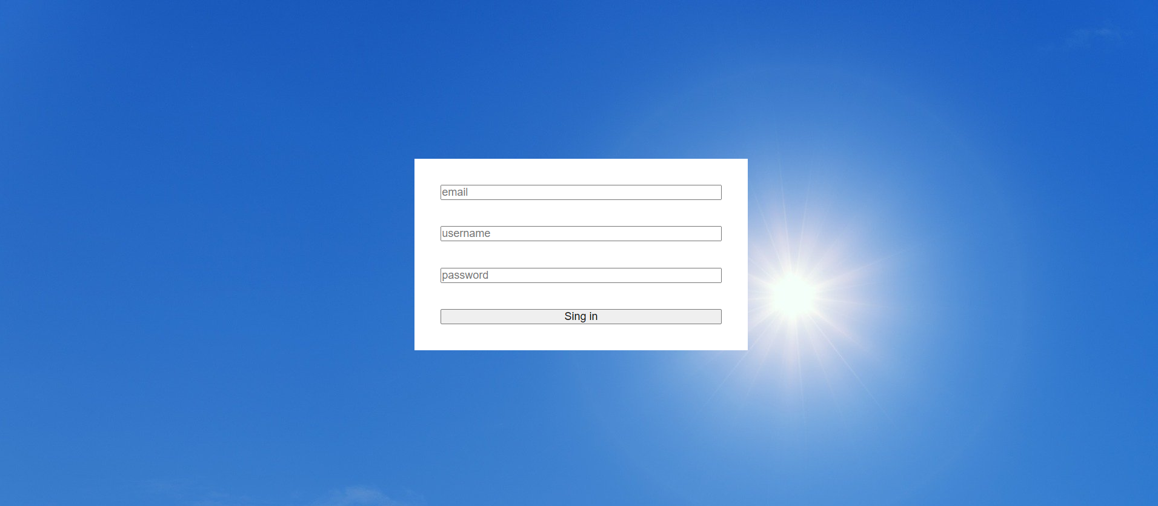

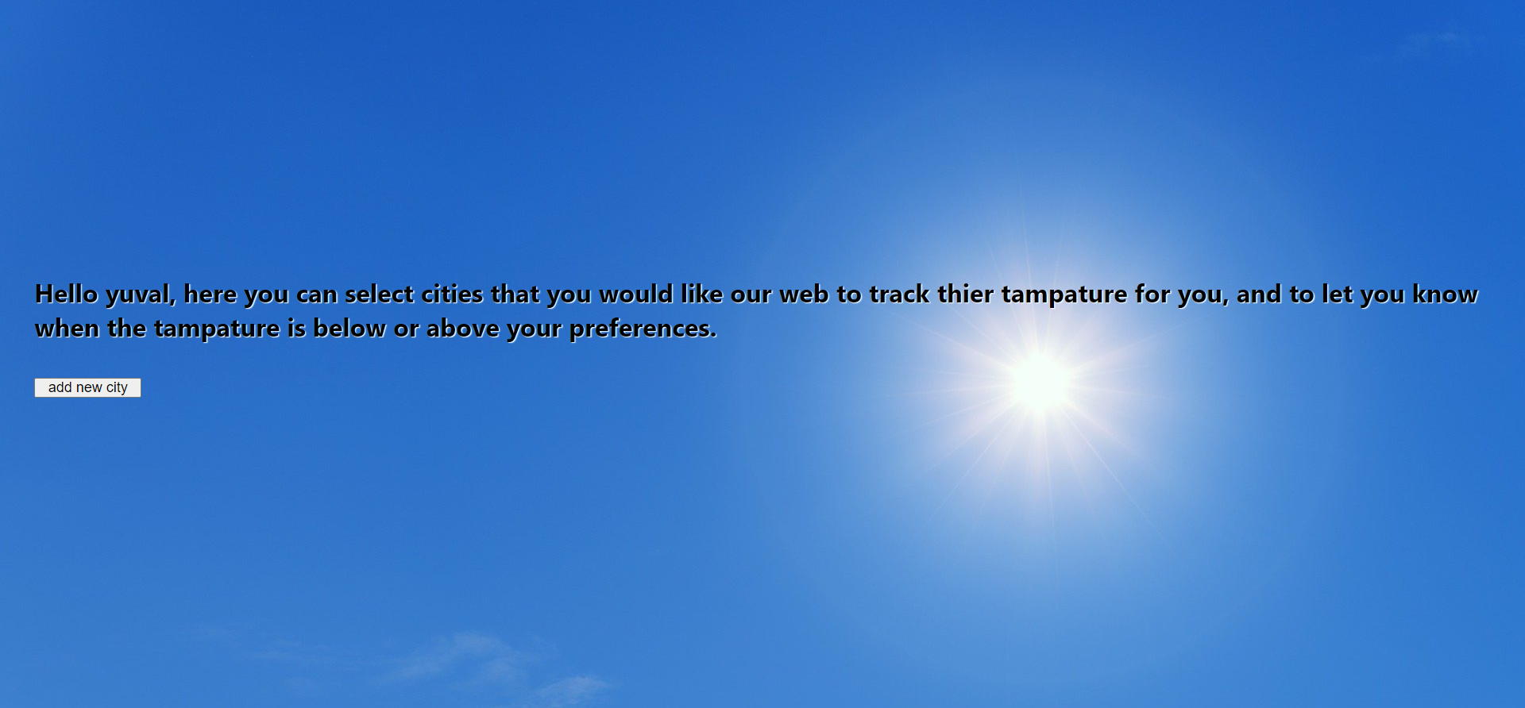

In order to receive updates to the email, the user simply needs to add his preferences to the site

